**Exercise 1: Configuring a Basic Spring Application**

**Scenario:**

Your company is developing a web application for managing a library. You need to use the Spring Framework to handle the backend operations.

**pom.xml:**

<project xmlns="http://maven.apache.org/POM/4.0.0"

xmlns:xsi="http://www.w3.org/2001/XMLSchema-instance"

xsi:schemaLocation="http://maven.apache.org/POM/4.0.0

http://maven.apache.org/xsd/maven-4.0.0.xsd">

<modelVersion>4.0.0</modelVersion>

<groupId>com.library</groupId>

<artifactId>LibraryManagement</artifactId>

<version>1.0.0</version>

<dependencies>

<dependency>

<groupId>org.springframework</groupId>

<artifactId>spring-context</artifactId>

<version>5.3.34</version>

</dependency>

</dependencies>

<build>

<plugins>

<plugin>

<groupId>org.apache.maven.plugins</groupId>

<artifactId>maven-compiler-plugin</artifactId>

<version>3.10.1</version>

<configuration>

<source>11</source>

<target>11</target>

</configuration>

</plugin>

</plugins>

</build>

</project>

**applicationContext.xml:**

<?xml version="1.0" encoding="UTF-8"?>

<beans xmlns="http://www.springframework.org/schema/beans"

xmlns:xsi="http://www.w3.org/2001/XMLSchema-instance"

xsi:schemaLocation="http://www.springframework.org/schema/beans

https://www.springframework.org/schema/beans/spring-beans.xsd">

<bean id="bookRepository" class="com.library.repository.BookRepository" />

<bean id="bookService" class="com.library.service.BookService">

<property name="bookRepository" ref="bookRepository" />

</bean>

</beans>

**BookRepository.java:**

package com.library.repository;

public class BookRepository

{

public String findBookById(int id)

{

return "Book{id=" + id + ", title='Spring in Action'}";

}

}

**BookService.java:**

package com.library.service;

import com.library.repository.BookRepository;

public class BookService

{

private BookRepository bookRepository;

public void setBookRepository(BookRepository bookRepository)

{

this.bookRepository = bookRepository;

}

public void displayBook(int id)

{

String bookDetails = bookRepository.findBookById(id);

System.out.println("BookService: Retrieved - " + bookDetails);

}

}

**MainApp.java:**

package com.library;

import com.library.service.BookService;

import org.springframework.context.ApplicationContext;

import org.springframework.context.support.ClassPathXmlApplicationContext;

public class MainApp

{

public static void main(String[] args)

{

ApplicationContext context = new ClassPathXmlApplicationContext("applicationContext.xml");

BookService bookService = context.getBean("bookService", BookService.class);

bookService.displayBook(101);

}

}

**Result:**

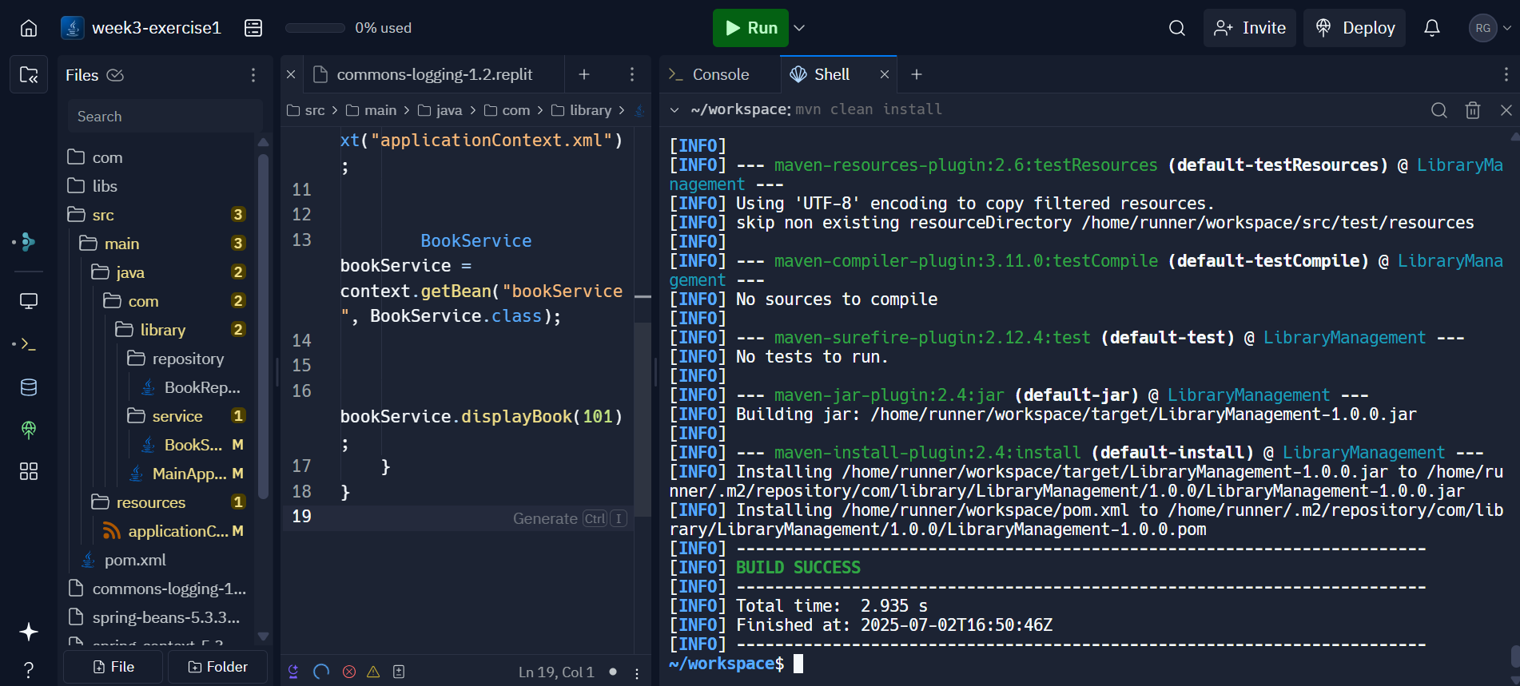

**Exercise 2: Implementing Dependency Injection**

**Scenario:**

In the library management application, you need to manage the dependencies between the BookService and BookRepository classes using Spring's IoC and DI.

**pom.xml:**

<project xmlns="http://maven.apache.org/POM/4.0.0"

xmlns:xsi="http://www.w3.org/2001/XMLSchema-instance"

xsi:schemaLocation="http://maven.apache.org/POM/4.0.0

http://maven.apache.org/xsd/maven-4.0.0.xsd">

<modelVersion>4.0.0</modelVersion>

<groupId>mygroupid</groupId>

<artifactId>myartifactid</artifactId>

<version>0.0-SNAPSHOT</version>

<dependencies>

<dependency>

<groupId>org.springframework</groupId>

<artifactId>spring-context</artifactId>

<version>5.3.30</version>

</dependency>

</dependencies>

<build>

<plugins>

<plugin>

<groupId>org.apache.maven.plugins</groupId>

<artifactId>maven-compiler-plugin</artifactId>

<version>3.8.1</version>

<configuration>

<source>17</source>

<target>17</target>

</configuration>

</plugin>

<plugin>

<groupId>org.codehaus.mojo</groupId>

<artifactId>exec-maven-plugin</artifactId>

<version>3.1.0</version>

<configuration>

<mainClass>com.library.LibraryManagementApplication</mainClass>

</configuration>

</plugin>

</plugins>

</build>

</project>

**applicationContent.xml:**

<beans xmlns="http://www.springframework.org/schema/beans"

xmlns:xsi="http://www.w3.org/2001/XMLSchema-instance"

xsi:schemaLocation="

http://www.springframework.org/schema/beans

http://www.springframework.org/schema/beans/spring-beans.xsd">

<bean id="bookRepository" class="com.library.repository.BookRepository" />

<bean id="bookService" class="com.library.service.BookService">

<property name="bookRepository" ref="bookRepository" />

</bean>

</beans>

**BookService.java:**

package com.library.service;

import com.library.repository.BookRepository;

public class BookService

{

private BookRepository bookRepository;

public void setBookRepository(BookRepository bookRepository)

{

this.bookRepository = bookRepository;

}

public void displayBooks()

{

bookRepository.findAllBooks().forEach(System.out::println);

}

}

**BookRepository.java:**

package com.library.repository;

import java.util.Arrays;

import java.util.List;

public class BookRepository

{

public List<String> findAllBooks()

{

return Arrays.asList("Java Basics", "Spring Framework", "Hibernate ORM");

}

}

**LibraryManagementApplication.java:**

package com.library;

import com.library.service.BookService;

import org.springframework.context.ApplicationContext;

import org.springframework.context.support.ClassPathXmlApplicationContext;

public class LibraryManagementApplication

{

public static void main(String[] args)

{

ApplicationContext context = new ClassPathXmlApplicationContext("applicationContext.xml");

BookService bookService = (BookService) context.getBean("bookService");

bookService.displayBooks();

}

}

**Result:**

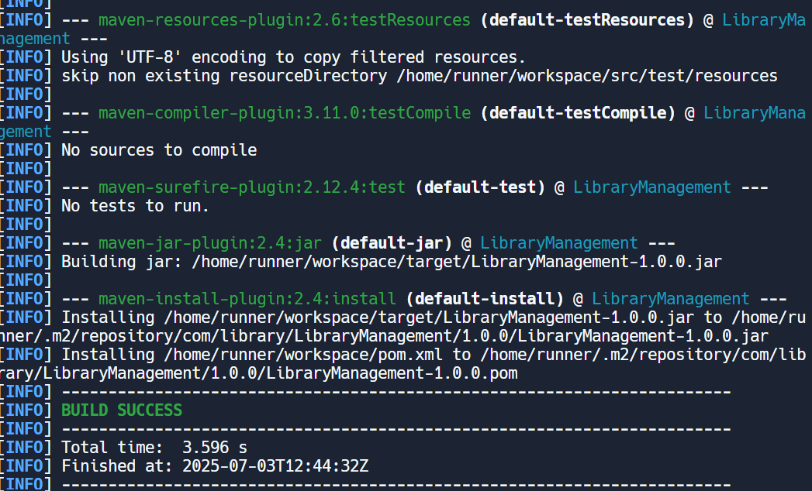

**Exercise 4: Creating and Configuring a Maven Project**

**Scenario:**

You need to set up a new Maven project for the library management application and add Spring dependencies.

**pom.xml:**

<project xmlns="http://maven.apache.org/POM/4.0.0"

xmlns:xsi="http://www.w3.org/2001/XMLSchema-instance"

xsi:schemaLocation="http://maven.apache.org/POM/4.0.0

http://maven.apache.org/xsd/maven-4.0.0.xsd">

<modelVersion>4.0.0</modelVersion>

<groupId>com.example</groupId>

<artifactId>librarymanagement</artifactId>

<version>1.0-SNAPSHOT</version>

<properties>

<java.version>1.8</java.version>

<project.build.sourceEncoding>UTF-8</project.build.sourceEncoding>

</properties>

<dependencies>

<dependency>

<groupId>org.springframework</groupId>

<artifactId>spring-context</artifactId>

<version>5.3.36</version>

</dependency>

<dependency>

<groupId>org.springframework</groupId>

<artifactId>spring-aop</artifactId>

<version>5.3.36</version>

</dependency>

<dependency>

<groupId>org.springframework</groupId>

<artifactId>spring-webmvc</artifactId>

<version>5.3.36</version>

</dependency>

</dependencies>

<build>

<plugins>

<plugin>

<groupId>org.apache.maven.plugins</groupId>

<artifactId>maven-compiler-plugin</artifactId>

<version>3.10.1</version>

<configuration>

<source>${java.version}</source>

<target>${java.version}</target>

</configuration>

</plugin>

</plugins>

</build>

</project>

**Library.java:**

package com.example.library;

public class Library

{

public void issueBook()

{

System.out.println("Book has been issued!");

}

}

**MainApp.java:**

package com.example.library;

import org.springframework.context.ApplicationContext;

Import org.springframework.context.annotation.AnnotationConfigApplicationContext;

public class MainApp

{

public static void main(String[] args)

{

ApplicationContext context = new AnnotationConfigApplicationContext(AppConfig.class);

Library lib = context.getBean(Library.class);

lib.issueBook();

}

}

**AppConfig.java:**

package com.example.library;

import org.springframework.context.annotation.Bean;

import org.springframework.context.annotation.Configuration;

*@*Configuration

public class AppConfig

{

*@*Bean

public Library library()

{

return new Library();

}

}

**Result:**

